Carbon Inventory Project - Carbon Day 2023

Please join us in spreading the word about the Carbon Inventory Project (CIP) and Carbon Day 2023.
This file provides materials and information for your use including:
- Project Background, Messaging, and Facts including Carbon Day 2023
- Images, Sample Posts, and Credit Lines
- Links to websites with CIP 2023 Fact Sheet of full project results and promotional New Buildings Institute blog
- List of Participants who opted to publicly share their organization’s name

PROJECT BACKGROUND
Energy use in buildings is one of the largest sources of carbon emissions worldwide. The buildings for museums, zoos and aquariums, gardens and historic sites use significant energy to light their gallery spaces, manage the temperature and humidity of their collections, and to power their shops, cafés, staff offices, and event spaces. Measuring and understanding energy use in museum buildings is both a high-return and low-risk effort for individual organizations, and sector-wide it has the potential for powerful collective action.

The Carbon Inventory Project (CIP) 2023 helped cultural organizations learn to measure, understand, and report their annual energy use. Participating organizations contributed their 2022 calendar-year results to the first U.S. cultural sector carbon footprint. Totals were announced on the first annual Carbon Day, June 16, 2023. With funding from an IMLS National Leadership grant, project leads Environment & Culture Partners, New Buildings Institute, and New England Museum Association offered free monthly presentations, office hours, and guidance using the EPA’s ENERGY STAR® Portfolio Manager® reporting tool.
Energy monitoring is a collective action for collective good, and it benefits individual cultural organizations and their community. Understanding how energy is used in building(s) may help target opportunities to save money, as well as create avenues to new funders and funding opportunities. It has the added benefit of preparing organizations for compliance with new or upcoming building codes and energy regulations. The public expects climate leadership from cultural organizations so while doing this work, organizations have the opportunity to mode climate awareness, action, and resiliency for their community.

MESSAGING
- For individual institutions, benchmarking energy data is a high-return, low-risk effort museums with multiple benefits:
  - Better energy and carbon management decisions
  - Saving money
  - Decreasing their carbon footprint
  - Preparing for pending building-related local policies and building codes
- Understanding the scale of the cultural sector’s total emissions is important for defining the scope of change necessary, attracting funding for changes, and reporting on the success of both funding and effort.
- Carbon Inventory Project participants represented a cohort of 80 museums, zoos, aquariums, historic sites, and science centers.
- The 80 institutions who participated in CIP manage a combined 20 million square feet of conditioned space, which equates to more than 450 acres. That's nearly the size of Disneyland Park and California Adventure combined or all of Disneyland in Anaheim, CA!
- The collective greenhouse gas (GHG) emissions associated with the 2022 energy consumption of CIP participants were more than 187,000 metric tons CO2e. This is equivalent to the annual emissions of over 41,000 gasoline-powered passenger cars.
- CIP participants reported an average GHG intensity ranging from less than zero (due to onsite renewables) to approximately 49 kgCO2e/ft2, with an overall average of around 9.6 kgCO2e/ft2. This metric will become increasingly important as more local jurisdictions adopt benchmarking requirements.
- CIP participants account for about 5% of the estimated 4 million metric tons of CO2e emitted by the entire cultural sector in 2022. If the entire sector made the effort to reduce their annual energy consumption by 20%, the related GHG emissions reductions would be equivalent to the annual emissions of 2 natural gas-fired power plants or 181,000 passenger vehicles.
- In late summer 2023:
  - The complete Culture Over Carbon report will be released which will include recommendations for energy management in cultural institutions.
  - The CIP Team and Environmental Protection Agency are collaborating on a survey to create a building performance category for museums in ESPM. The survey will require 200+ participants.

FACTS
- Culture Over Carbon: Understanding Museums’ Energy Use and The Carbon Inventory Project are funded by an Institute of Museum and Library Services National Leadership Grant. Partners include the New England Museum Association, New Buildings Institute, and Environment & Culture Partners.
- The Carbon Inventory Project is part of the Culture Over Carbon Research Project.
- 2023 is the first year Carbon Day will occur. Carbon Day is June 16. Carbon’s atomic number is 6 (June). Oxygen’s atomic number is 8 – there are two of them in Carbon Dioxide (so 8 x 2 = 16). Establishing an annual day to measure carbon consumption allows organizations to create a habit to plan for, measure, and report on energy consumption.
- Energy consumption from buildings accounts for ~40% of global direct and indirect greenhouse gas emissions (Source: New Buildings Institute, Building Industry Steps Up to Address Climate Change, Nov 2022)
- There are over 35,000 museums in the U.S. (Source: Institute of Museum and Library Services, “Government Doubles Official Estimate: There are 35,000 Active Museums in the U.S.”, May 2014)
- Many gases such as carbon dioxide significantly contribute to global warming, all of which together are quantified in a single metric called CO2e. CO2e indicates the total metric tons of greenhouse gases emitted as a result of the reported annual energy consumption.

CONTENT
Below please find supporting information including Images, Partner Usernames, Links, and Sample Posts.

Hashtags
Please use the hashtags #CarbonDay2023 and #CarbonInventoryProject.

Images
Please include the Carbon Inventory Project images where possible. Images are located on pages 6-9.

Partner Usernames
Please use the following usernames to promote CIP.
Platform | ECP | NBI | NEMA | IMLS
Twitter | @EnvCulturePrs | @NewBldgsInst | @NEMAnet | @US_IMLS
Facebook | @EnvCulturePrs | @NewBuildingsInstitute | @New England Museum Association | @USIMLS
Instagram | @EnvCulturePrs | @NewBuildingsInstitute | @Nema_conference | N/A
LinkedIn | @Environment & Culture Partners | @New Buildings Institute | @New England Museum Association | N/A

Links
The Carbon Inventory Project website with CIP 2023 Fact Sheet of full project results
Long URL: https://ecprs.org/engagement/carbon-inventory-project/
Short URL: https://tinyurl.com/LearnCIP

New Buildings Institute CIP Blog: https://newbuildings.org/first-annual-carbon-day-in-june-will-establish-a-carbon-benchmark-for-the-u-s-cultural-sector/

The Culture Over Carbon study website
Long URL: https://ecprs.org/engagement/culture-over-carbon/
Short URL: https://tinyurl.com/LearnCOC

SAMPLE POSTS
The 2023 Carbon Inventory Project (CIP) is an initiative to both encourage museums to benchmark their energy usage and calculate a U.S. museum-wide carbon footprint. The Carbon Inventory Project is funded by an Institute of Museum and Library Services National Leadership Grant. Partners include the New England Museum Association, New Buildings Institute, and Environment & Culture Partners.
Additional content:
- Contributing to the effort to calculate a museum sector-wide carbon footprint is important because [insert].
- Discovering ways to become more energy efficient and decrease our carbon footprint is important/impactful because [insert].
- Pursuing climate initiatives such as benchmarking our energy is a priority/a new priority because [insert].

CREDIT LINE
Please always credit Environment & Culture Partners, New Buildings Institute, the New England Museum Association and Institute of Museum and Library Services when promoting your participation. Suggested credit lines:
Sample #1:
The Carbon Inventory Project was made possible by Environment & Culture Partners, New Buildings Institute, New England Museum Association, and Institute of Museum and Library Services.
Sample #2:
The Carbon Inventory Project was made possible by ECP, NBI, NEMA, and IMLS. #CarbonInventoryProject

2023 CIP PARTICIPANTS
Some museums participated anonymously; the following institutions opted to share their names as participants in CIP:
Academy Museum of Motion Pictures, Aldrich Contemporary Art Museum, Anchorage Museum, Art Museum of Southeast Texas, Atlanta History Center, Blithewold, Carnegie Museum of Art, Carnegie Museum of Natural History, Carnegie Science Center, Chicago Children's Museum, Clark Art Institute, COSI, Customs House Museum and Cultural Center, Denver Art Museum, Edsel & Eleanor Ford House, Exploratorium, Hauser & Wirth, Henry Art Gallery, Henry Vilas Zoo, Historic New England, Kansas City Zoo, La Plata County Historical Society - Animas Museum, Long Island Children's Museum, Madison Children's Museum, Meeteetse Museum District, Museum of Contemporary Art Chicago, Museum of Discovery and Science, Museum of Russian Icons, Museum of Science (Boston), National Nordic Museum, Oakbrook Park Chumash Indian Corporation, Phipps Conservatory and Botanical Gardens, Science Museum of Minnesota, SFMOMA, Smithsonian Institution, The Andy Warhol Museum, The Henry Ford, The Wild Center, Toledo Museum of Art, Wilson Museum, and Yale University Art Gallery.

CIP TEAM
For any questions regarding the Carbon Inventory Project, Culture Over Carbon, or other related materials, please contact hello@ecprs.org.

Facebook
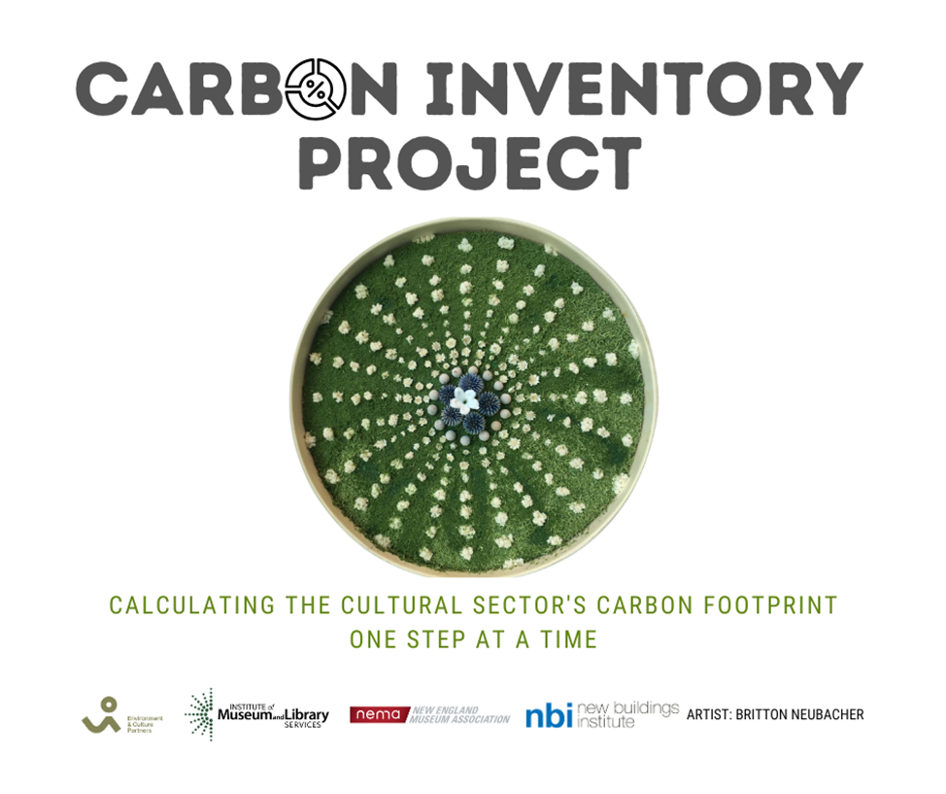

Instagram
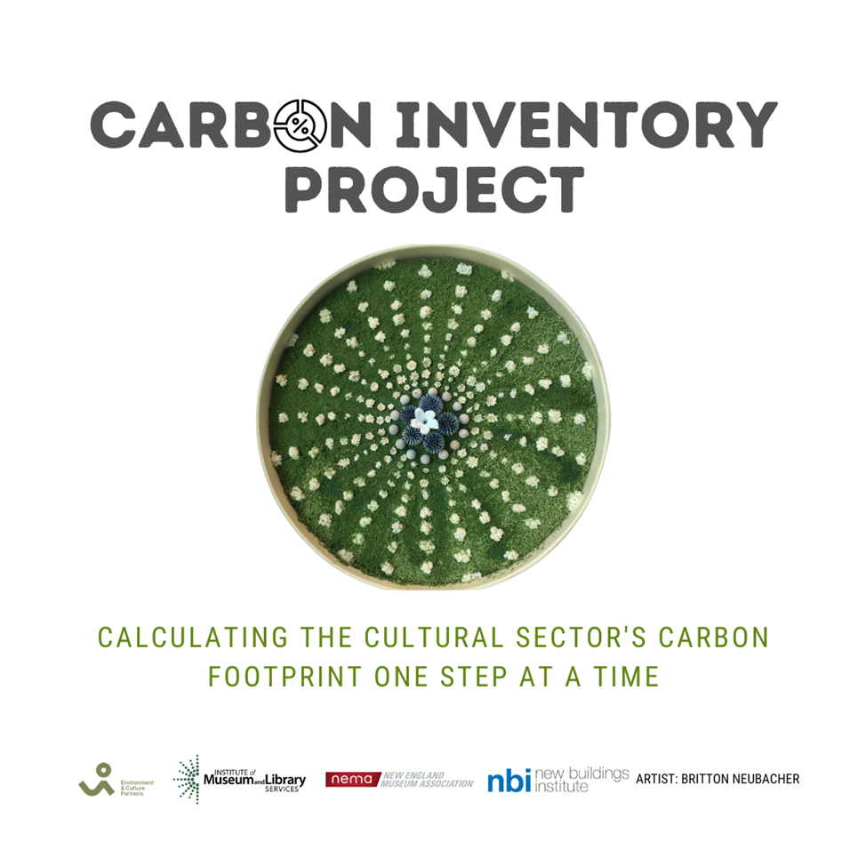

Twitter
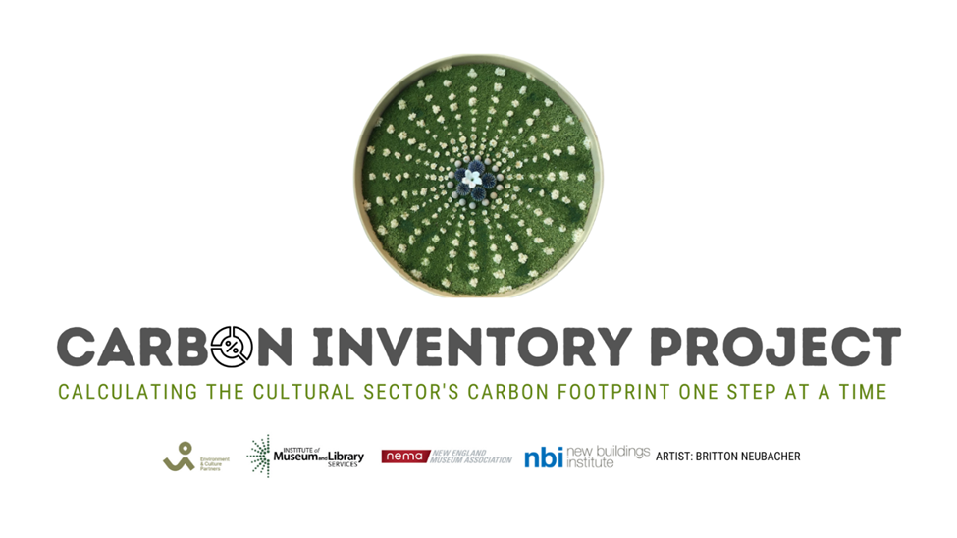

LinkedIn
